**Database- Day -3: MongoDB:**

1. Find all the information about each products

Query: db.taskdata.find()

1. Find the product price which are between 400 to 800

Query: db.taskdata.find({product_price:{$gte:400,$lte:800}})

1. Find the product price which are not between 400 to 600

Query: db.taskdata.find({$or:[{product_price:{$lt:400}},{product_price:{$gt:600}}]})

1. List the four product which are greater than 500 in price

Query:db.taskdata.find({product_price:{$gt:500}}).limit(4)

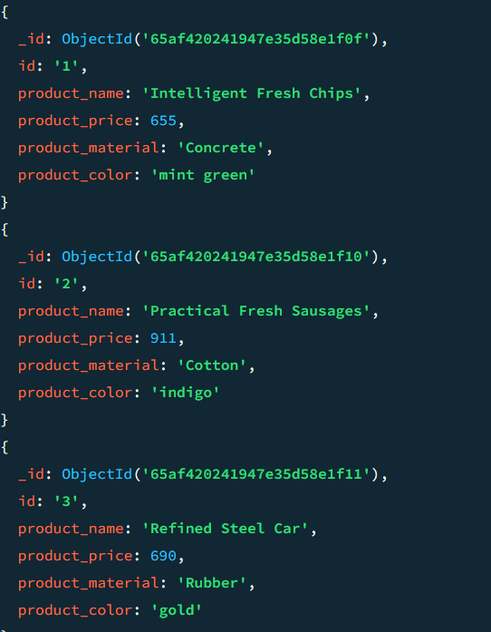

1. Find the product name and product material of each products

Query: db.taskdata.find().projection({

product_name: 1 , product_material:1

})

1. Find the product with a row id of 10

Query: db.taskdata.find({id:'10'})

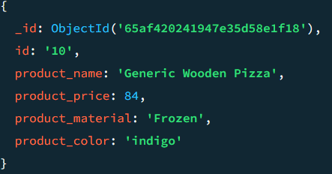

1. Find only the product name and product material

Query: db.taskdata.find().projection({

product_name: 1 , product_material:1

})

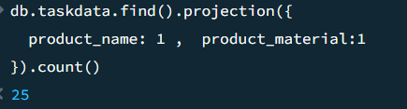

1. Find all products which contain the value of soft in product material

Query: db.taskdata.find({product_material:{$eq:"Soft"}})

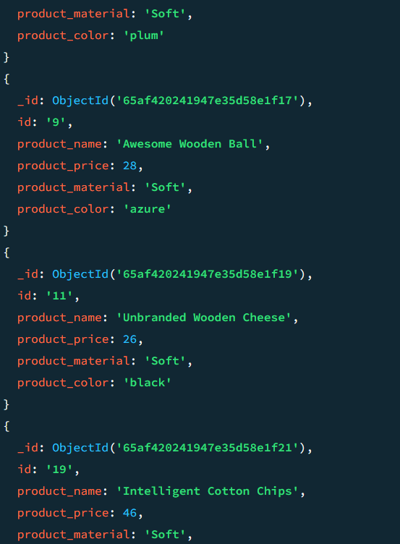

1. Find products which contain product color indigo and product price 492.00

Query: db.taskdata.find({$and:[{product_price:{$eq:492.00}},{product_color:{$eq:"indigo"}}]})

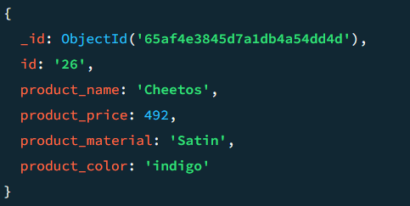

10.Delete the products which product price value are same

